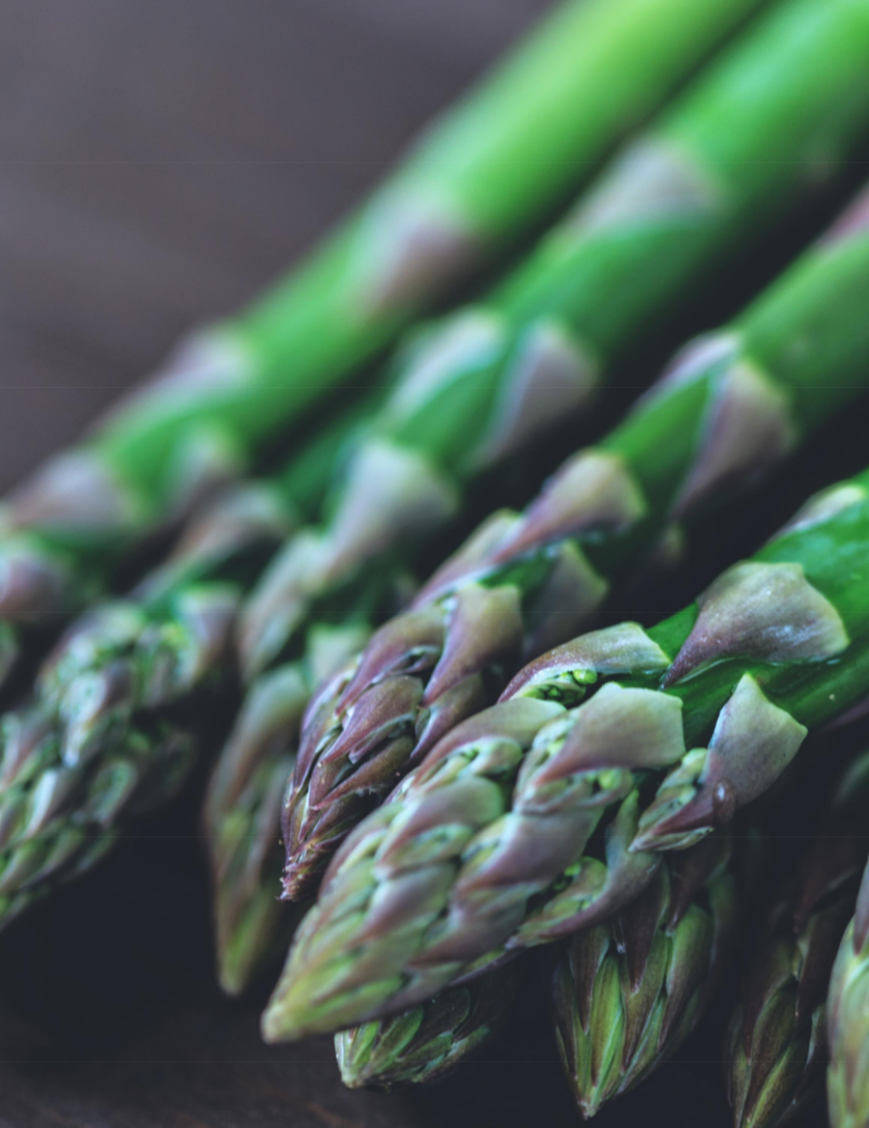

E A T I N G F O R T H E S E A S O N S :
Spring

A FUNCTIONAL CHINESE MEDICINE APPROACH TO NUTRITION BY JULIE ODLER AND SHARON PRUSS


"Let Food be

Your Medicine"

Eating for the Seasons: A Functional CM Guide to Nutrition • 2018 1

Introduction

Western nutrition is a wonderful therapeutic model used for making adjustments to improve our overall health. However:

- It tends to focus on/over-emphasize calories and the micronutrients protein, carbohydrates, and fat without any further discussion about how individual foods affect us.

- It doesn't tend to feel natural or instinctive.

For example, we know that eating a donut has an entirely different affect on our body than eating an equal amount of broccoli. That's obvious. But eating a jalapeno pepper has a different effect on us than eating a lemon or mint tea. Eating a hearty chili or stew is very much indicated for many of us in the winter, but would weigh us down in the spring and summer..

Doing a juice cleanse may be beneficial in the spring and summer, but not such a good idea in mid-winter when our bodies need more nourishment and foods to help us rebuild, sustain, and enhance immunity. (Fall and winter are "yin" seasons)

Let's start by taking a look at the 5 Flavors from a healing perspective:

Eating for the Seasons: A Functional CM Guide to Nutrition • 2018 2

Flavors and Energetics of Food

- Sour: Wood element: Helps us process fat

- Bitter: Fire element: Helps control inflammation and supports liver function

- Sweet: Earth element: Nourishes muscles by replacing glycogen stores

- Astringent: Metal element: Helps clear congestion.

  - Salty: Water element: Our bodies do need sodium, along with other minerals in order to function. Salt also helps us feel “grounded”
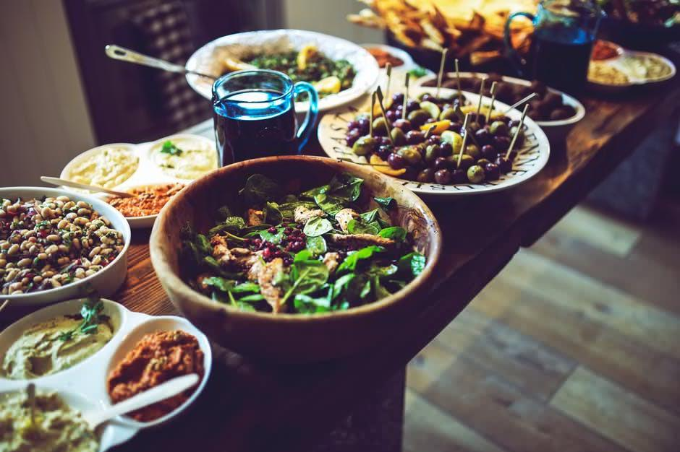

Eating for the Seasons: A Functional CM Guide to Nutrition • 2018 3

Flavors and Energetics of Food

At every meal, it is beneficial to experience every taste:: Sweet, Sour, Salty, Bitter, and Astringent. These flavors represent all the energetics of the 5 elements: Earth, Wood, Water, Fire, and Metal. If you think about it, it makes sense. The sweet and salty flavors are the basics. As humans, we tend to crave these foods for basic calories/survival.

Foods such as apples, rice, and bread have a naturally sweet flavor. Other foods are naturally salty, such as fish, meat, certain vegetables, and even cheeses and fermented foods.

The astringent, pungent, and bitter flavors are often overlooked in

the United States, but are worth exploring!. Far from boring, many a "foodie" may spend most of his or her food budget on vinegars, oils, spices, pastes, or explore different types of onions, garlic, and peppers.

These flavors contain phytonutrients, anti-inflammatory agents, and can help take health to the next level "beyond the basics.." Balancing these flavors is also one of the "secrets" for maintaining a healthy weight.

Eating for the Seasons: A Functional CM Guide to Nutrition • 2018 4

How? Many in Western cultures are addicted to the taste of either extreme salt or extreme sugar. Blame it on the food industry, which intentionally creates foods to be as addicting as possible.

Conversely, the same happens when you try to be “good” and subsist on iceberg lettuce, yogurt, and microwaved processed foods, even (especially) the ones marketed as being healthy. You will be missing out on the energetic benefits of foods that will nourish your body and feel MUCH more satisfying. This habit isn't sustainable, and sooner or later more and more energetically dead foods like diet ice cream end up in your cart. Overeating is how your body tells you it isn't getting what it needs.

Mother nature has a truly amazing way of providing exactly what our bodies need for each season since the beginning of time. This is the most “ancestral” way of eating, regardless of where your DNA comes from, whether you follow a plant-based or more Paleo-based diet, a Mediterranean, or Asian diet.

The ancient Chinese viewed our bodies as being a natural extension of our surroundings, of the environment, and the seasons.

Eating for the Seasons: A Functional CM Guide to Nutrition • 2018 5

Spring: The Wood Element
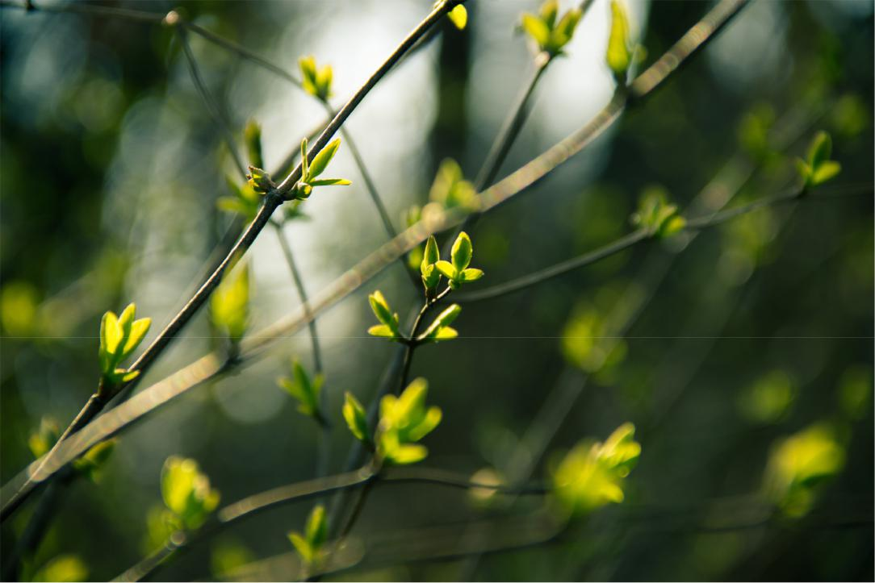

This is the season of the Liver and Gallbladder organ systems. Don’t

worry too much about how they function, but know that this is a different concept from the western view, although there is some overlap. If you want to learn more, I recommend the book The Web That Has No Weaver by Ted J. Kaptchuk.

In our modern culture, this is the time when many begin to switch to a

more plant-based diet, focusing on fresh greens. The taste that is represented by this element is sour, but many of us also crave bitter tastes, or are at least more open to the idea in the spring.

Eating for the Seasons: A Functional CM Guide to Nutrition • 2018 6

Spring: The Wood Element
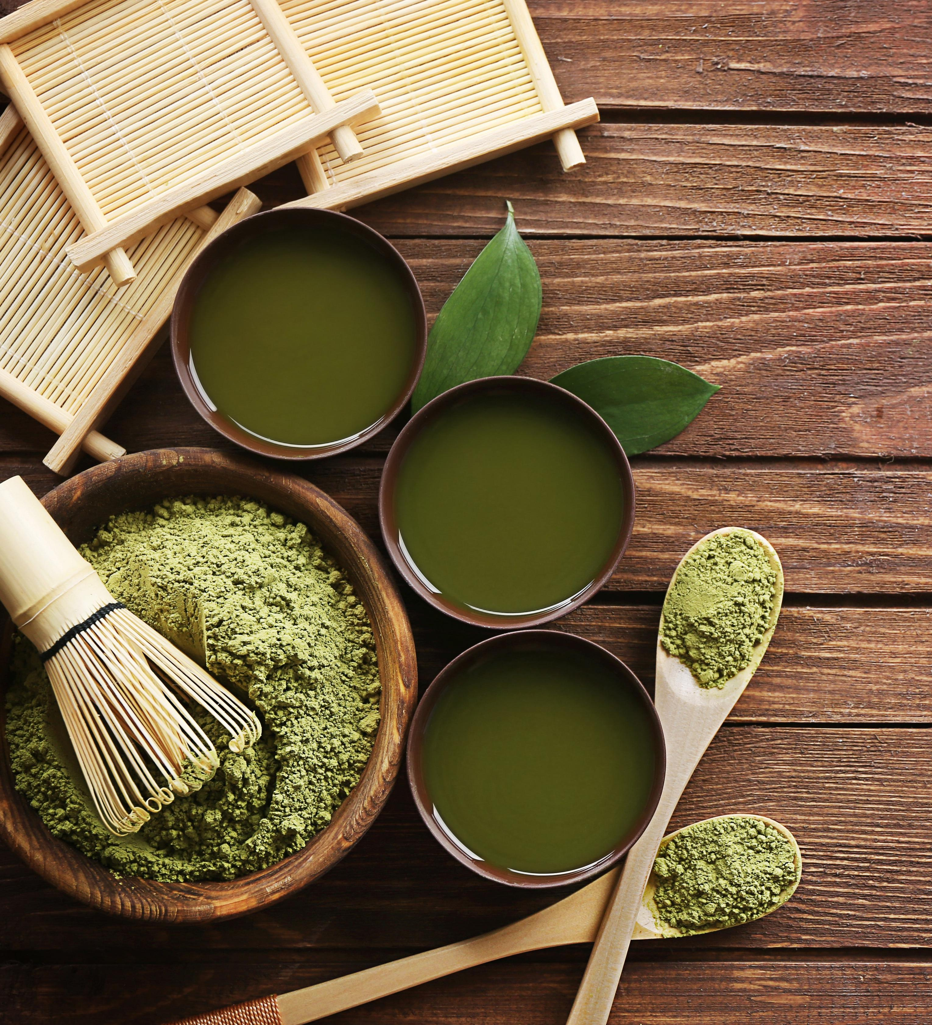

It is represented by the color green.

We may also be moving away from the “salty” taste, which is representative of winter, or the “kidney” organ system. Energetically, winter is more about “going within” and reflection, rather than expansion. Spring is the opposite. It is hard to expand when our bodies are weighed down with heavy, salty, and “earthier” or more grounding foods. “Naturally, this helps us clear out all the “heaviness” or “stagnation” from the winter months.

We naturally desire to feel lighter, to create what some may refer to as an “internal spring.” In Ayurvedic medicine, spring and the wood element can be compared to “vata” or “wind” energy. This encourages quickness in thinking and movement, as opposed to the “grounding” and “yin/reflective” energy of fall and winter.

The foods we tend to consume in the spring are often cleansing.

Indeed, cleanses have become even more popular lately.

Eating for the Seasons: A Functional CM Guide to Nutrition • 2018 7

A word about "detoxing"

Some opt do a a juice cleanse in the spring. My philosophy regarding cleanses is to do it slowly and gently. Your digestive system should also be healthy: I never recommend cleanses or detoxes if someone is constipated or experiencing poor digestive health. In this case I recommend a consultation so we can work together to get to the root cause of your digestive issues.

Now is the time when your body is in natural alignment for "detoxing" as the warmer weather, the desire to feel "lighter" and embrace a more "yang" or "energy using" season. is here. But don't OVERDO it.. Detoxing is a process that could backfire when done incorrectly.

You can still "lighten up" by choosing to go with the seasons and opt for fresh spring greens and experimenting with sour and bitter flavors. Think of it less of a detox and more of a satisfying culinary experience.
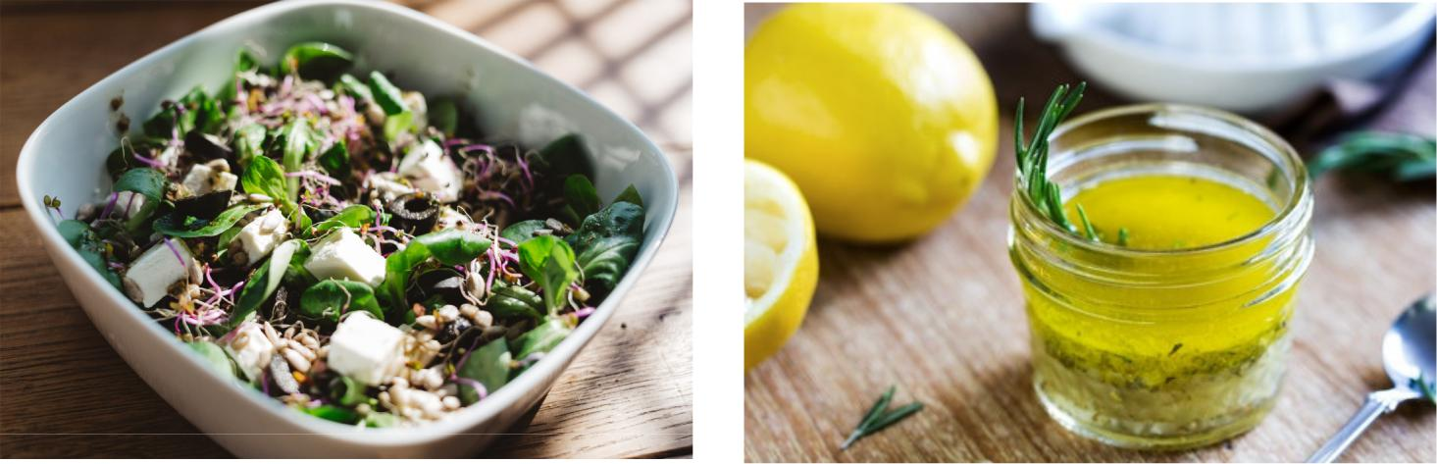

Eating for the Seasons: A Functional CM Guide to Nutrition • 2018 8

Common Wood Element Imbalances

:1. Liver Qi stagnation. Have you ever felt irritable and heavy after eating the wrong kind of food, being “stuck” inside all day, feeling “stuck” on a project or life event that has you feeling frustrated? Has this ever caused headaches, digestive problems, or PMS? Somewhat similar to a sub-optimally functioning liver and gallbladder in western medicine (but not exactly the same thing)

Liver Qi Stagnation is a condition that we naturally heal ourselves from via a lighter diet or movement of some kind. Feeling “stuck” or “stagnant” can feel unpleasant. We eat lightly or decide to move because we naturally crave the free movement of “qi” or energy. LQS is very, very common in our modern culture because of our stress levels. I

Liver Qi Stagnation is often related to (but not the same thing as) hormone imbalances such as estrogen dominance and PMS, impaired liver function, headaches, depression, and almost any disease related to STRESS.

Eating for the Seasons: A Functional CM Guide to Nutrition • 2018 9

Common Wood Element Imbalances

Spring: A word about cellulite

I tend to look at cellulite as being a problem with Liver yin deficiency, Liver qi stagnation, and dampness or blood stagnation in varying degrees. This condition is mainly about the lack of blood flow and oxygen to connective tissues (qi and blood) the buildup of toxins (to include excess circulating estrogen, which can happen EVEN IF a woman is estrogen deficient) and fluids being in the wrong places in the body (interstitial, or outside of cells) instead of inside the cells. This has a lot to do with the lymphatic system, or perhaps in TCM, the San Jiao system.

It is also closely related to certain hormone imbalances, such as a progesterone deficiency or estrogen dominance. Cellulite is not just about being “fat” as many fitness gurus like to preach. Yes, carrying excess fat can exacerbate cellulite, but even women in very good shape (not just skinny fat) can have cellulite, so it needs to be looked at from several perspectives. Liver yin deficiency is also very common.

Eating for the Seasons: A Functional CM Guide to Nutrition • 2018 10

Foods to Nourish Your "Liver Yin"

Some liver yin tonifying foods include:
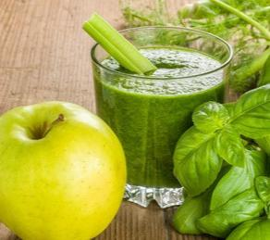

- Coconut water

- Almost any fresh fruit or vegetable that isn’t pungent or drying (such as hot peppers)

- Cucumbers

- Pears

- Apples

- Mangoes

  - Flax seeds

- Foods with lots of antioxidants, like blackberries or even dark chocolate. (Coffee is not great for nourishing yin, unfortunately. It has the opposite effect)

- Foods rich in collagen, such as bone broths (also great for “tonifying” blood)

Eating for the Seasons: A Functional CM Guide to Nutrition • 2018 11

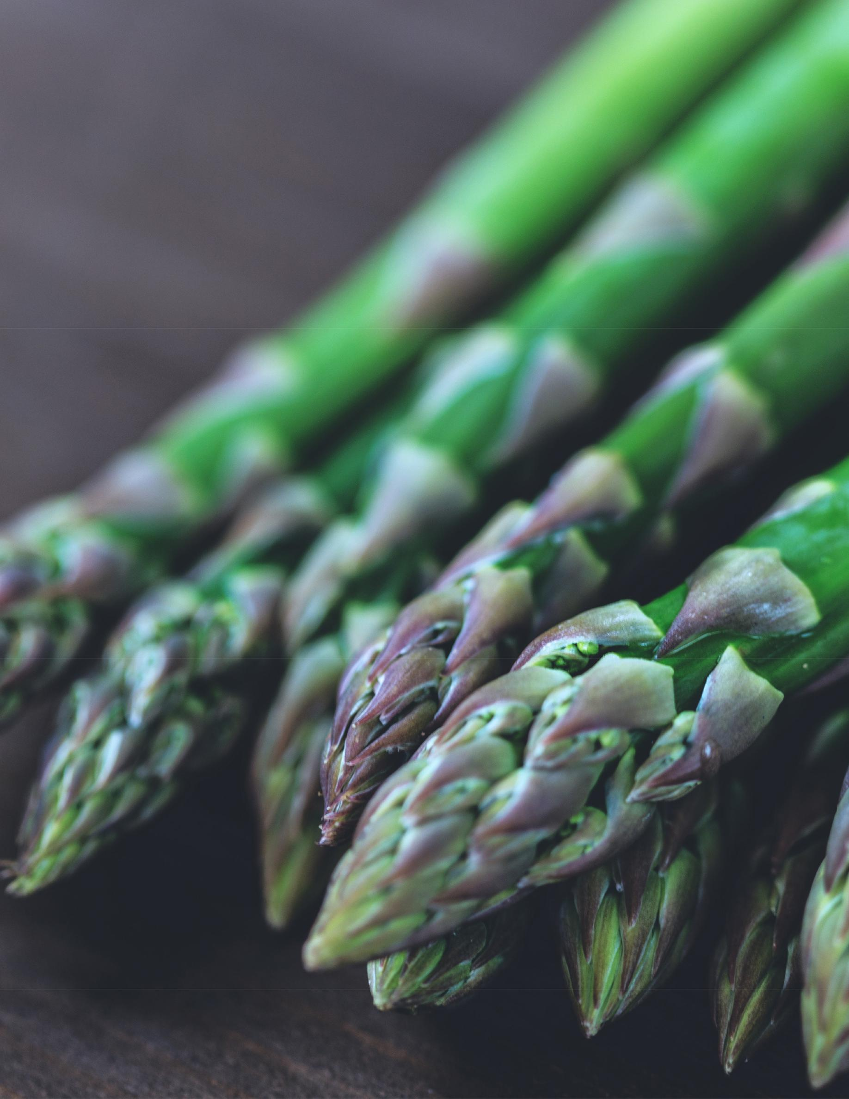
Healing Foods for Spring

BEST HEALING FOODS FOR THE WOOD (spring) SEASON

(These will address both Liver Qi Stagnation and Liver Yin Deficiency)

LOTS of fresh green vegetables, particularly younger varieties, such as

baby kale or arugula

Berries in season

Peas

Young carrots

Young beets

Lentils Chickpeas

Quinoa

Oats

Chicken

Fish

Shrimp

Rosemary

Lemons

Green Tea

Eating for the Seasons: A Functional CM Guide to Nutrition • 2018 12

Want to know more?

Good nutrition is the foundation of good health and is an essential part of my healing protocols for almost every condition. Food IS medicine!

To find out more about how to use food to heal your specific condition.. anything from autoimmune conditions to hormonal weight gain to even headaches and joint pain, give me a call at 310.621.4553.

\

Eating for the Seasons: A Functional CM Guide to Nutrition • 2018 13

